20140417

Here is how tu configure TotalCommander for ftp access.
Solomkin Anton said me this solution.

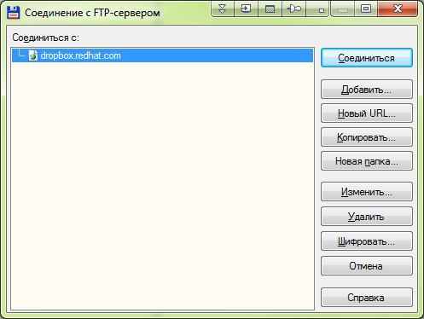

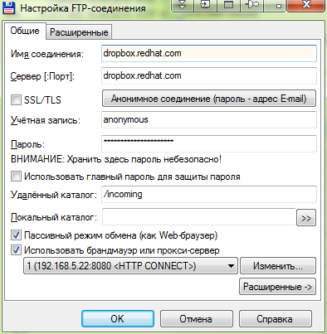

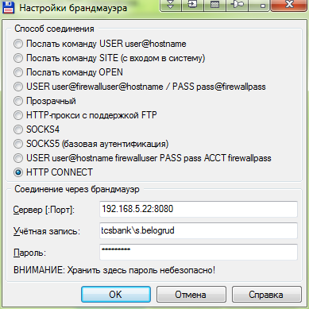

https://access.redhat.com/site/solutions/2112

How to provide large files to Red Hat Support (vmcore, rhev logcollector, large sosreports, heap dumps, large log files, etc.)

Issue
- How to provide large files to Red Hat Support (vmcore, rhev logcollector, large sosreports, heap dumps, large log files, etc.)
- How to upload files to Red Hat's FTP dropbox.redhat.com?
- Customer portal case screen allows to upload files less then 250MB only. How to upload large files to Red Hat Technical Support?

Environment
- Red Hat Global Support Services anonymous FTP - dropbox.redhat.com
- File size greater than 250 MB that needs to be sent to Red Hat Global Support Services

Resolution

Contents
- FTP
- Secure FTP
- Red Hat Support Tool
- Upload files via Customer Portal

FTP
- Red Hat has a publicly available anonymous FTP site where anyone can upload files that may not be uploaded correctly to the Red Hat Customer Portal.
- These files can be uploaded to the anonymous FTP site dropbox.redhat.com, and placed in the /incoming directory. When logging in to the FTP server, please provide the username "anonymous" and use your email address as the password.
- Prior to uploading the file please compress the file using gzip or zip and uniquely name the resulting archive file. The recommended name prefix should be your case number followed by a date or time string or other uniquely identifying information. For example:
$ tar czf /tmp/001234-$(date +%s)-vmcore.tar.gz myvmcore
$ tar czf /tmp/001234-$(date +%s)-logs.tar.gz mylogdir/
- If the file is very large, you can split it in parts (without causing problem to its content) and then upload it. Refer How do I reliably upload large files to a blind FTP server?
- When the file is successfully uploaded, please provide the support engineer with the exact file name and MD5 or SHA1 message digest of the uploaded files.
- Note:
  - No files can be downloaded from this FTP site
  - The files listed under the /incoming directory on this site can not be seen nor can a new directory be created
  - You will not be able to overwrite an existing file so ensure a unique name is used
  - You will not be able to resume an upload as this requires the ability to write to an existing file
  - Ensure all files are transferred in binary format (not text or ASCII mode)
  - Ensure you are using passive FTP mode
  - If your firewall does not allow passive FTP mode you may connect to origin-dropbox.redhat.com using active mode.
- Here's a quick walk through:
- $ ftp dropbox.redhat.com
Connected to dropbox.redhat.com (XXX.XXX.XXX.XXX).
220 (vsFTPd 2.0.1)
Name (dropbox.redhat.com:user): anonymous
331 Please specify the password.
Password: user@domain
230 Login successful.
Remote system type is UNIX.
Using binary mode to transfer files.
ftp>
  - If it says "Using text mode to transfer files", then you need to change the transfer mode to binary by typing "bin"
- ftp> bin
200 Switching to Binary mode.
ftp>
  - Change to the /incoming directory
- ftp> cd incoming
+---------------------------------------------------------------+
| Welcome to Red Hat Global Support Services FTP! |
| |
| Please note: the "ls" command is disabled by design. |
| You will receive this error if you attempt to run "ls": |
| |
| ls: 550 Permission denied. |
| |
| If you are uploading a file for Technical Support, you |
| must include your support ticket number in the filename |
| and inform your technician of the upload. Files with names |
| that do not follow this convention, such as vmcore or |
| vmcore.gz will be deleted. |
| |
| To upload a core successfully, please do the following: |
| |
| ftp> cd incoming |
| ftp> put [casenumber]-[file] |
| |
| - Passive transfers are supported, if you require active |
| transfers please connect to origin-dropbox.redhat.com |
| - Upload resume is supported. |
+---------------------------------------------------------------+
250 Directory successfully changed.
ftp>
  - You will notice that you cannot do an "ls" to list the files in /incoming nor can you create a new directory. This is intentional.
  - You can start uploading the files by using the "put" command. Most users should enable passive mode. For example, if you are using ftp command in Linux, run "passive" to toggle the Passive mode to "on":
- ftp> passive
Passive mode off.
ftp> passive
Passive mode on.
ftp>
  - For Windows ftp command, run "literal pasv" to change to passive mode:
- ftp> literal pasv
227 Entering Passive Mode (XXX,XXX,XXX,XXX,XXX,XX)
ftp>
  - The proceed to upload the file:
- ftp> put [filename]
  - And type "bye" when you finished uploading the files
- ftp> bye
221 Goodbye.
- To compute the MD5 or SHA1 message digest of the files you uploaded, you can run
$ md5sum [filename]
or
$ sha1sum [filename]

Secure FTP
- In addition to the process described above, dropbox.redhat.com now supports uploading files using encrypted data connections through the use of the FTP-ES (explicit mode; "require explicit FTP over TLS") protocol.
- For example, "testfile" can be uploaded using FTP-ES using the "lftp" console FTP client in the following fashion (backslash separated for clarity):
# lftp -v -c 'open -e "set ftps:initial-prot ""; \
set ftp:ssl-force true; \
set ftp:ssl-protect-data true; \
set ssl:verify-certificate true; \
open anonymous:ftp@dropbox.redhat.com ; \
cd incoming ; \
put testfile'

Red Hat Support Tool
- To upload files directly from your system, you can also use Red Hat Support Tool (redhat-support-tool). It gives you flexibility and also scripting capabilities. The simplest way to upload a normal-size file, e.g.: sosreport, is this:
$ redhat-support-tool addattachment -c CASE_NUMER /path/to/sosreport
- This will upload your file directly to the Customer Portal. If you want to upload to the FTP site, use the "-f" option:
$ redhat-support-tool addattachment -c CASE_NUMER -f /path/to/sosreport
- If you have a very big vmcore file and you don't have access to the Dropbox FTP site, you can split your file with the "-s" option to upload it to the Customer Portal:
$ redhat-support-tool addattachment -c CASE_NUMER -s /path/to/vmcore
- The facility has also been tested using the multi-platform GUI FTP client from http://filezilla-project.org/.

Upload files via Customer Portal
- Refer Attaching files for attaching files with less than 250 MB size via Red Hat Customer Portal.

